Jeff Shapiro

jeff@shapirohousehold.com

Bowen Theatre Company

Documentation

# Contents

Contents 1

Description 2

User interface requirements 2

Design 3

Original Design 3

Final Design – Select Seat Empty 4

Final Design – Select Seat with entry 5

Final Design – Select Seat showing ‘Available’ tool tip 6

Final Design – Ticket Details popup -with details 7

Final Design – Ticket Details popup -available 7

Functionality 8

4 rows x 6 columns of dynamically generated seat selection buttons 8

Clear form button to remove and reset all fields 8

Field entry validation 8

Ticket Type amended based on date of birth. 8

Seat status is displayed on hover. 8

On left click of seat. 8

On right click of seat. 8

Details are stored in dynamic structure array. 8

Data storage 8

Algorithm 9

Description

Bowen Theatre Company is a custom made application for the Bowen Theatre Company to enable electronic bookings. Targeting the general public, the application has been designed to do as much of the work for you as possible making the program useable on a very simple skill level. Seat options are dynamically generated with status updates displayed on change.

# User interface requirements

The application can run on any hardware which supports windows 7 or later. The system must have at least 100MB of free disk space to install the program and recommended minimum of 1GB of memory to load the application.

# Design



Original Design

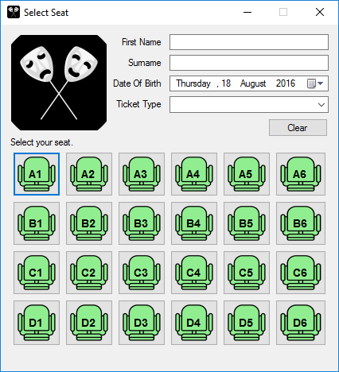

### Final Design – Select Seat Empty

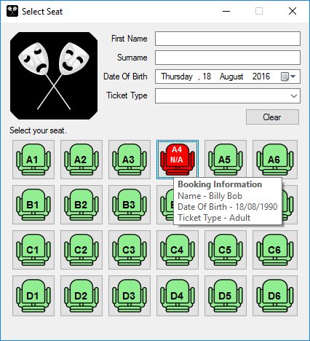

### Final Design – Select Seat with entry

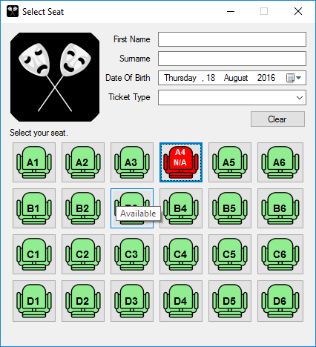

### Final Design – Select Seat showing ‘Available’ tool tip

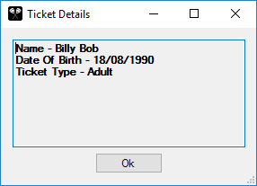

### Final Design – Ticket Details popup -with details

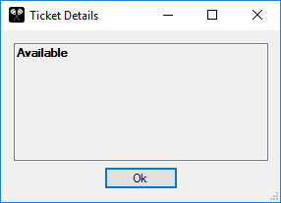

### Final Design – Ticket Details popup -available

# Functionality

### 4 rows x 6 columns of dynamically generated seat selection buttons

### Clear form button to remove and reset all fields

### Field entry validation

* First Name must be 2 or more letters
* Surname must be 2 or more letters
* Date of Birth cannot be today
* Ticket Type cannot be blank

### Ticket Type amended based on date of birth.

* Child must be less than 14
* If over 14 Child ticket cannot be selected
* If date of birth is put above 14 years Child ticket type will be removed. If then reduced to less than 14 years Child ticket type will be restored.

### Seat status is displayed on hover.

* If seat is available, the tooltip will display – Available
* If seat has been reserved, the tooltip will display – Booking details will be displayed

### On left click of seat.

* If fields are all filled in and valid. Will store information and clear all fields
* If fields are filled in and invalid. Message will display advising which fields are invalid
* If fields are all filled in and valid, and selected seat is reserved. Message will be displayed advising of the situation.

### On right click of seat.

* If seat is available, popup form will display – Available
* If seat has been reserved, popup form will display – Booking details will be displayed

### Details are stored in dynamic structure array.

* First Name
* Surname
* Date of Birth
* Ticket Type
* Seat Status

### Data storage

* Automatic save on close
* Automatic retrieve on open
* Clear seat data

Algorithm

